Summary 1
Queens road 1
Clarendon Park aread 1
Welford road area 2

Summary

Summary of the site experience I gained on Monday 17th November 2025.

1- Installed a fuse connection unit and double socket as part of the radial circuit in an outhouse.
2 - Shadowed an electrician as he installed cables into a kitchen area that had damp course protection. I did not do too much in this project.
3 - Shadowed an electrician installed a timer for the customer’s outside front garden lights.

Queens road

In the queens road area, a resident had recently refurbished his outhouse. Upon arrival I discovered that the outhouse had plaster board and plaster applied. The task was to install a double socket and a fuse connection unit which was to be adjacent to a mount wall electric heater.
I used the multi-tool in order to cut out two areas to insert both the double-socket and the fuse connection unit. One challenge that I encountered was with the double socket box. Behind the plaster board was brickwork for the external kitchen wall. However, there was hardly any space between the brickwall and the plasterboard. At least not enough for a plastic back box. I know because I tried. Therefore, we used a metal double socket box because it was smaller in comparison. In addition, the usage of a metal back box meant that the double socket sat flush with the plasterboard wall.

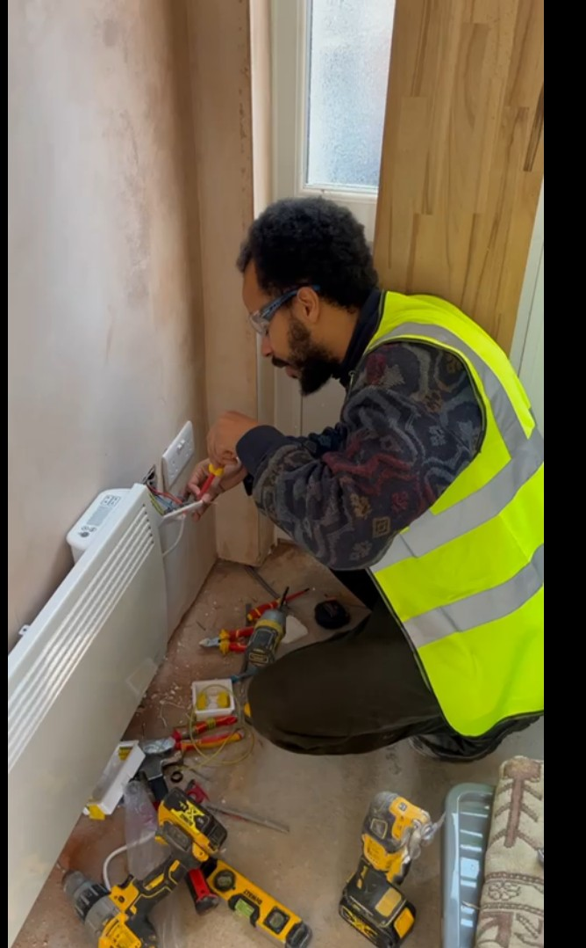

While the metal back box was in the cut out. I marked with a sharpie pen where the holes were against the brickwall. I then drill into the brickwall and put wall socket plugs into the insertions. I put back the metal back box and screwed two screws firmly into the wall plugs. This tightened the double socket to the brickwork.

Another challenge that I encountered was with the double socket. The holes in the double socket back box had been worn out. This meant I faced difficulty when I tried to secure the socket front to the socket back box through the socket pins. My electrical supervisor used a re-threader tool to re-define the holes in the socket box. In addition, he used a snip tool with a screw cut feature to shorten the length.
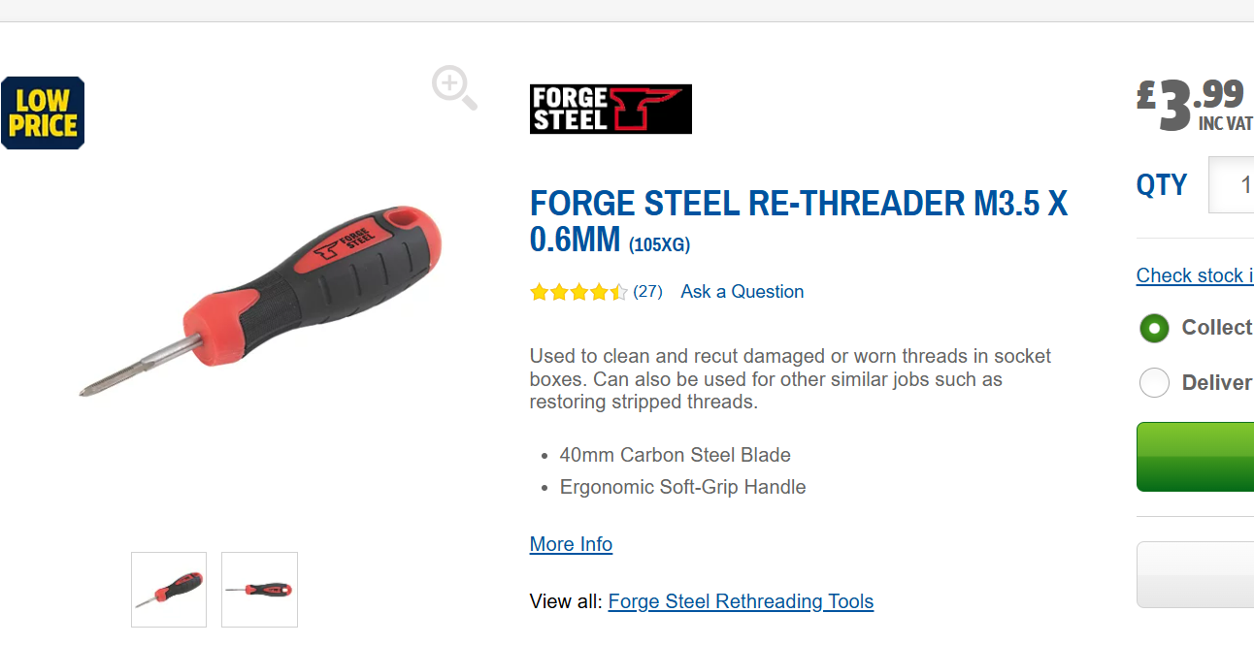

This was a significant part of the day and without the re-threader I would have been in despair. Also I gained a small amount of comprehension in relation to radial circuits as well because I could envision that circuit behind the plasterboard and how all components were connected.

I have produced a small electrical diagram to illustrate the terminal connections.

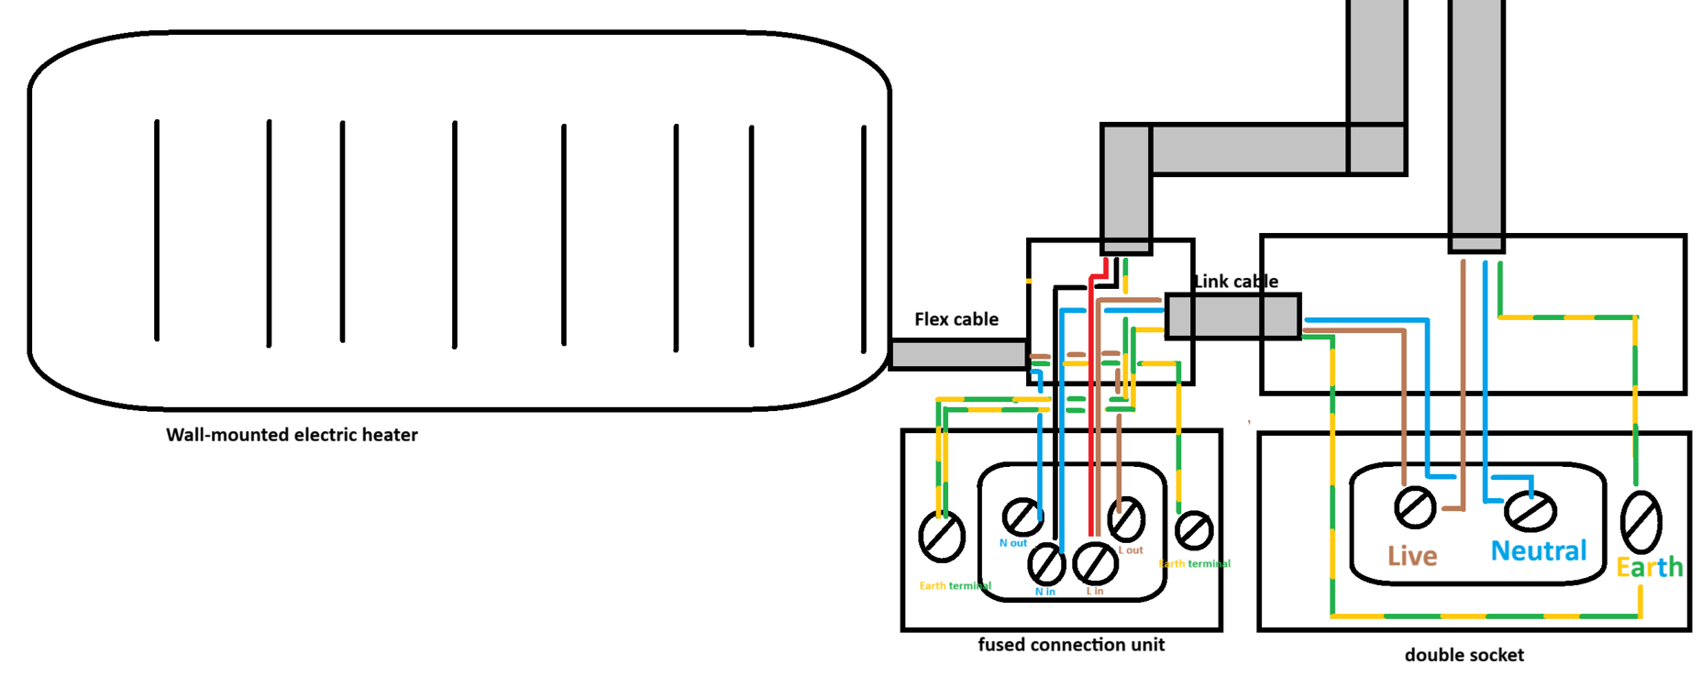

Clarendon Park aread

The resident is in the process of a brand new kitchen install. All I did was clip the twin and earth cable into place.

Welford road area

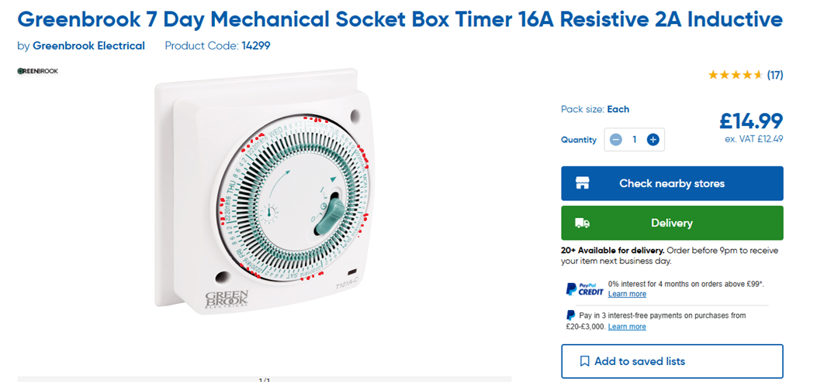

Another great way to end the day. We went to a neighbourhood around the Welford road area and the resident wanted the timer to switch on the outside lights between 16:00 and midnight.

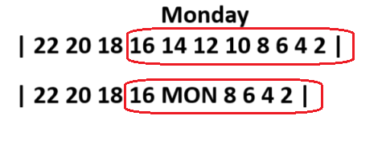

The dial obeys the 24 hour clock scheme. The supervisor knocked down the pin that corresponded to the hours aforementioned.

